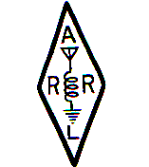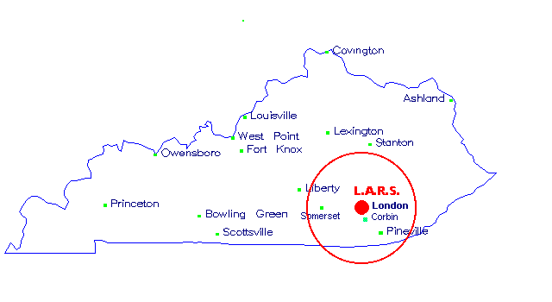

October 1, 2011 Volume XXI, Number 10
L. A. R. S. Lines, the newsletter of the Laurel Amateur Radio Society, is published monthly in written and in email format as a service to its membership and to the amateur radio community. Officers of the Laurel Amateur Radio Society for the year 2011 are:
Peter Rock KJ4ND …………….……… President
Billy J. Russell N4ICU ……….………. Vice-President
Stanley Baker KD4ERF……………… Secretary / Treasurer

Minutes of the September Meeting
Thursday 1 September 2011 6:30 P.M.

The September monthly meeting of the Laurel Amateur Radio Society was the Skywarn Spotter Class which was held on September 1, 2011 at 6:30 p.m., local time, at the Fire Alliance Training Facility, located in London, Kentucky on the 192 By-Pass. The training class was taught by Mr. Tony Edwards, Warning Coordination Meteorologist with the NOAA/National Weather Service, in Jackson, Kentucky.
Thanks, Tony! I have received reports that the class was excellent! I regret that I had to be in Lexington on the day of the class and did not return in time to see it personally. Thanks go to John Whitaker KG4LFY for providing us with some pictures taken at the class.
The Fire Alliance Training Facility was under some re-modeling at the time but things seem to have worked out just fine. Our thanks go to John Whitaker KG4LFY for providing the newsletter with some pictures of the event. With all the severe storms that have been taking place in this area over the past several months, the training that Tony Edwards provided will enable those attending to respond more efficiently to help protect our communities should a severe weather event approaches.
As we have done in past years when a weather spotter class is held, no official club business was conducted so that the main emphasis could be upon learning the life and property saving knowledge of how to identify and deal with severe weather events that occur too often in this area.
We wish to extend a sincere thanks to all those at the Jackson Office of the NOAA/National Weather Service.
-----Minutes by Stanley Baker KD4ERF, Sec./Treasurer
* * * * ** * * * * * * * * * * * * * * * * * * *
IMPORTANT NOTICE !!!!!
The October monthly meeting of the Laurel Amateur Radio Society is scheduled for 7:00 p.m., local time, on Thursday evening, October 6, 2011 at the Fiesta Mexicana Restaurant near the Kroger and Advance Auto Parts store opposite the new Dino’s (formerly Laurel Landing) at traffic lights #6 of the 192 By-Pass off Exit 38 off Interstate 75 at London, KY. The meeting will feature a discussion of the information learned at the Skywarn Spotter Training Class held last month and a discussion of plans for the remaining meetings of this calendar year.

* * * * ** * * * * * * * * * * * * * * * * * *

Pictures of the Skywarn Spotter Training Class

Tony Edwards of the Jackson Office of the National Weather Service conducts the Skywarn Spotter Training Class at last month’s montly meeting…

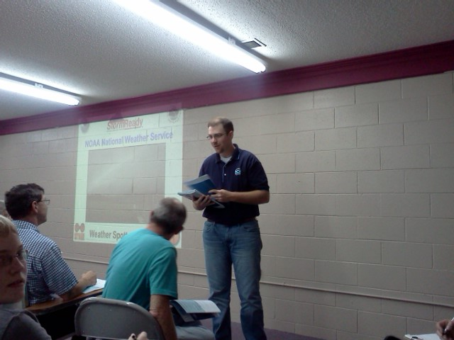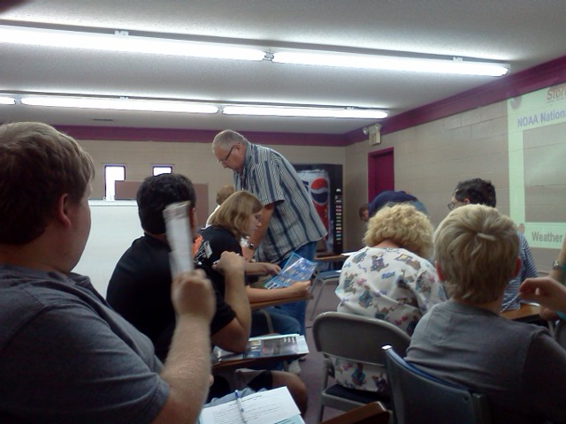

Amid the remodeling at the fire training facility, Tony Edwards conducts the Skywarn Weather Spotter Class while club vice-president, Jim Russell N4ICU in the second picture gives us an expression of satisfaction!

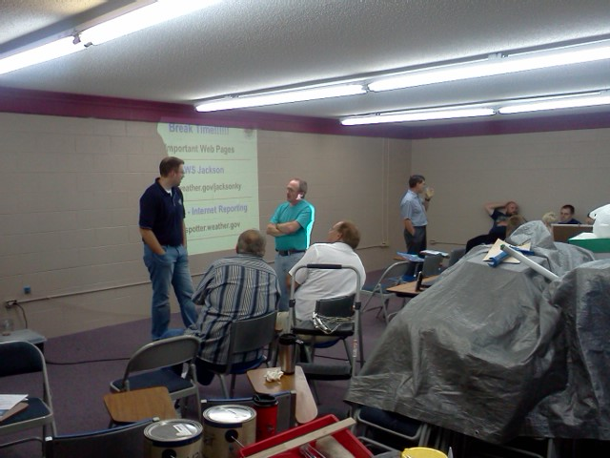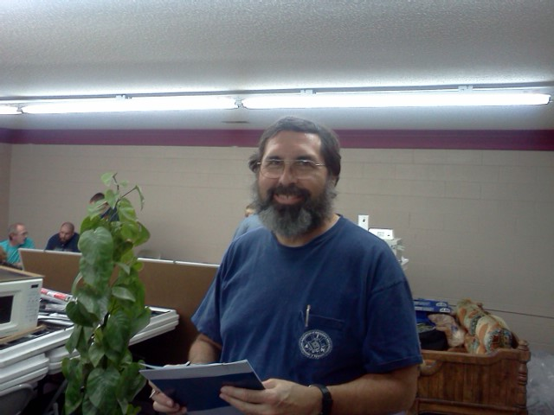

* * * * ** * * * * * * * * * * * * * * * * * *

What is SKYWARN®?
The effects of severe weather are felt every year by many Americans. To obtain critical weather information, NOAA's National Weather Service (NWS), part of the U.S. Department of Commerce, established SKYWARN® with partner organizations. SKYWARN® is a volunteer program with nearly 290,000 trained severe weather spotters. These volunteers help keep their local communities safe by providing timely and accurate reports of severe weather to the National Weather Service.
Although SKYWARN® spotters provide essential information for all types of weather hazards, the main responsibility of a SKYWARN® spotter is to identify and describe severe local storms. In the average year, 10,000 severe thunderstorms, 5,000 floods and more than 1,000 tornadoes occur across the United States. These events threatened lives and property.
Since the program started in the 1970s, the information provided by SKYWARN® spotters, coupled with Doppler radar technology, improved satellite and other data, and has enabled NWS to issue more timely and accurate warnings for tornadoes, severe thunderstorms and flash floods.
SKYWARN® storm spotters are part of the ranks of citizens who form the Nation's first line of defense against severe weather. There can be no finer reward than to know that their efforts have given communities the precious gift of time--seconds and minutes that can help save lives.
Who is Eligible?
NWS encourages anyone with an interest in public service and access to communication, such HAM radio, to join the SKYWARN® program. Volunteers include police and fire personnel, dispatchers, EMS workers, public utility workers and other concerned private citizens. Individuals affiliated with hospitals, schools, churches, nursing homes or who have a responsibility for protecting others are also encouraged to become a spotter.
How Can I Get Involved?
NWS has 122 local Weather Forecast Offices, each with a Warning Coordination Meteorologist, who is responsible for administering the SKYWARN® program in their local area. Training is conducted at these local offices and covers:
Basics of thunderstorm development
Fundamentals of storm structure
Identifying potential severe weather features
Information to report
How to report information
Basic severe weather safety
Classes are free and typically are about two hours long. To find
a class in your area:
Go to: http://www.stormready.noaa.gov/contact.htm and click on your state
When your state comes up, click on the name of your Weather Forecast Office
Once at your local WFO home page, in the blue bar on the left, look for the SKYWARN link to find a schedule of classes and other local information.
SKYWARN® is a registered trademark of NOAA's National Weather Service. Rules for the usage of the SKYWARN® name and logo are available here.

* * * * ** * * * * * * * * * * * * * * * * * * *
FCC Call Sign Update for Region 4
Extra – AK4MD
Technician, & General – KK4DXH

* * * * * * * * * * * * * * * * * * * * * * * * *

Next Meeting Date: Thursday, October 6, 2011, at 7:00 p.m., local time, at the Fiesta Mexicana Restaurant near the Kroger and Advance Auto Parts store opposite the new Dino’s (formerly Laurel Landing) at traffic lights #6 of the 192 By-Pass off Exit 38 off Interstate 75 at London, KY. This meeting features the discussion of the Severe Weather Training by the personnel of the Jackson Office of the National Weather Service which was held during the September meeting time. Discussion of the plans for the remaining meetings of the current year will be on the agenda.

Mid-Month Meeting: Thursday, October 20, 2011, at 12:00 noon, at Fazoli’s on the 192 By-Pass at Exit 38 off Interstate 75 at London, KY.

Membership: $15.00 /year

L. A. R. S. Lines Newsletter

Laurel Amateur Radio Society

Peter Rock (KJ4ND) .........................President
Billy J. Russell (N4ICU) ….…..Vice-President
Stanley E. Baker (KD4ERF).............Sec/Treas.
Correspondence address:
Stanley E. Baker (KD4ERF)
12 Boggs Road
London, Kentucky 40744-8260
Phone: 606- 877-1534 cell phone: 606-309-8452
Fax: 606-877-1534 Texting: use cell phone above
E-mail: sbaker@sebaker.com

DO NOT FORGET THE L. A. R. S. EMERGENCY NET EACH SUNDAY EVENING AT 9:00 P.M., LOCAL TIME, ON THE WD4KWV 146.61 REPEATER!!!!!

DO NOT FORGET THE SOUTHEAST SKYWARN WEATHER NET EVERY OTHER (2nd) THURSDAY EVENING AT 9:00 P.M., LOCAL TIME, ON THE KG4LKY 146.925MHz (-)79.7 PL REPEATER LINKED TO THE 444.275MHz (+)79.7 PL KF4IFC REPEATER AND ECHO NODE 16883 !!! THIS NET IS CONDUCTED BY TONY W4WXR.

***************************************************
FOR SALE:
If any of you, know anyone that needs a brand new 56kv90

